**Change Log**

|  |  |  |  |  |
| --- | --- | --- | --- | --- |
| **SR No.** | **CR ID / Release ID / Defect ID / Incident Number** | **Date** | **Change details** | **Sections affected** |
| 1 | SCPCR_10010 | 16.04.2021 | New Document | ALM Fields: All  Attachment Sections : All |

**RICEF Overview**

SAP Enhancement (RICEFW): The functionality described in the linked BPAC is realized with the below described RICEFW

Table of contents

1. Purpose 5

2. Landscape 6

3. Data Flow 7

**1.** **User Maintenance-> External/ Internal** 7

1. User ID Creation 7

2. User flag for deletion 7

**2.** **Customer Master Creation in HANA DB-> Enter the Customer number** 8

**3.** **Material Master** 8

**4.** **Item Category Master** 9

**5.** **Customer Assignment** 9

**6.** **Material Item Category Assignment** 10

**7.** **Order Simulation** 10

**8.** **Order Simulation and Creation** 11

**9.** **Customer KPI** 11

4. Function Calls 12

5. NAME OF THE OPERATION 13

1.1 Manifest 13

1.2 App 14

1.4 Controllers 14

1.4.1 HOME.CONTROLLER.JS 14

1.4.2 APP.CONTROLLER.JS 14

1.4.3 USERMAINTENANCE.CONTROLLER.JS 15

1.4.4 CUSTOMERMASTER.CONTROLLER.JS 16

1.4.5 MATERIALMASTER.CONTROLLER.JS 19

1.4.6 ITEMCATEGORY.CONTROLLER.JS 19

1.4.7 AUDITTRAIL.CONTROLLER.JS 20

1.4.8 Orders.controller.JS 20

1.4.9 ApproveOrders.controller.JS 20

1.4.10 ProcessOrders.controller.JS 21

1.4.11 OrderReport.controller.JS 21

1.4.12 NewOrder.controller.JS 21

2.1 Display, Create, Update, Delete User 22

2.2 Display, Create, Update, Delete User Customer Assignment 24

2.3 Display, Create, Update, Delete Customer 27

2.4 Display, Create, Update, Delete Customer Material Assignment 30

2.5 Display, Create, Update, Delete Customer Ship to Party Assignment 31

2.6 Display, Create, Update, Delete Customer FTRADE Assignment 34

2.7 Display, Create, Update, Delete Material Master Create 36

2.8 Display, Create, Update, Delete Material Item Category Assignment 38

2.9 Display, Create, Update, Delete Customer Material Item Category Assignment 40

2.10 Orders Display Service 41

3. Gateway Services: 43

3.1 Design Summary 43

3.2 Detailed Design 44

3.3 Function Module:- YSD_FM_VALIDATE_MATERIALS 44

3.4 Function Module:- YSD_FM_VALIDATE_CUSTOMER 45

3.5 Function Module:- YSD_FM_SO_GETSALESAREA 45

3.6 Function Module:- YSD_FM_MIN_ORDER_FOR_MATERIAL 45

3.7 Function Module:- YSD_FM_SO_SIMULATE 46

3.8 Function Module:- YSD_FM_SO_CREATE 47

3.9 Backend OData Details: 47

3.10 Table for the maintaining the system details: 49

6. ERP Functions: 49

7. Authorization 50

a. Cloud Platform 50

b. HANA 50

c. End to End 50

8. User onBoarding 51

9. SDI / SLT 51

10. Error Messages 51

11. **Appendix** 52

1. Purpose

This document should give an overview and detailed description of the App “MOET”. It includes a landscape explanation, data flow and also a detailed frontend and backend implementation description of the App itself.

MOET App is responsible for placing the Order details by a User. The user will login into the App with credentials and enter the Order reference number or they place a new order by entering the Customer ID, Ship to Party ID, PO type, Customer number, Customer PO date etc. and at the line item level they can add the material, quantity, requested delivery date etc. Once the user done with entering all the details they will click the simulate button and in the backend relevant Gateway services will call the respective ERP systems (LEAN/TEMPO) for the fetching the details like pricing procedure, schedule line details against the materials entered in the App. After confirming at simulation a temporary Sales Order number will be generated at the HANA database and stored in a custom table and sent out for approvals. Once SNO (1st Level Approver) log-in into the application he will be able to see all the orders which are pending for his approval will be displayed under the approve order section where he can review and take respective action to Approve/Review. If order is Reviewed by the approver then status of the Order will Change to “SNOR” and will be back to the open Order lists. To approve the Sales Order, the approver has to select the following and click ‘Submit’ button:

1. Leadtime within the frozen horizon
2. Ideal/Incremental Minimum order quantity
3. Check Versus Forecast
4. Fit to Contract Conditions

Once the order submitted the pop up message will be display with Sales Order number created in the backend.

1. Landscape

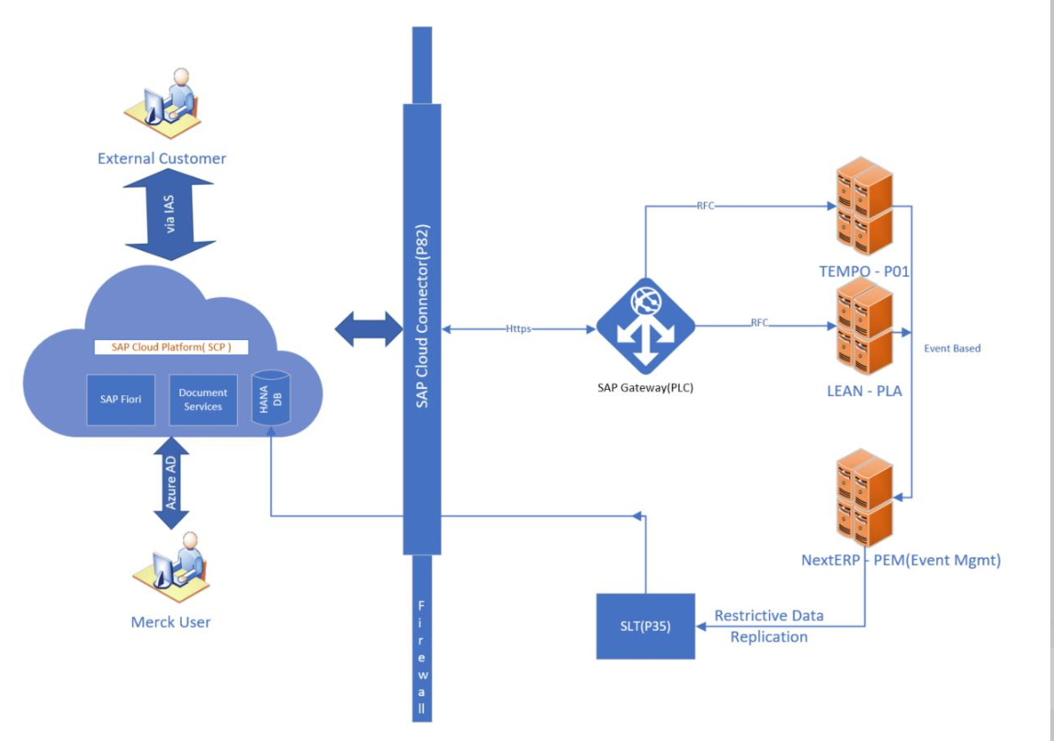

4

**Involved Systems are:**

|  |  |  |  |
| --- | --- | --- | --- |
| **System** | **Development** | **Quality** | **Production** |
| SAP CC (Cloud Connector) | SCP-DEV | SCP-QUA | SCP-PROD |
| SAP HANA | SCP-DEV | SCP-QUA | SCP-PROD |
| SAP Gateway | ALC/DLC | QLC | PLC |
| SAP ERP - LEAN | DLA | QLA | PLA |
| SAP ERP - TEMPO | C01 | Q01 | P01 |
| SAP EM | DEM | UEM | PEM |
| SAP SLT | D35 | Q35 | P35 |

1. Data Flow
2. **User Maintenance-> External/ Internal**
3. User ID Creation

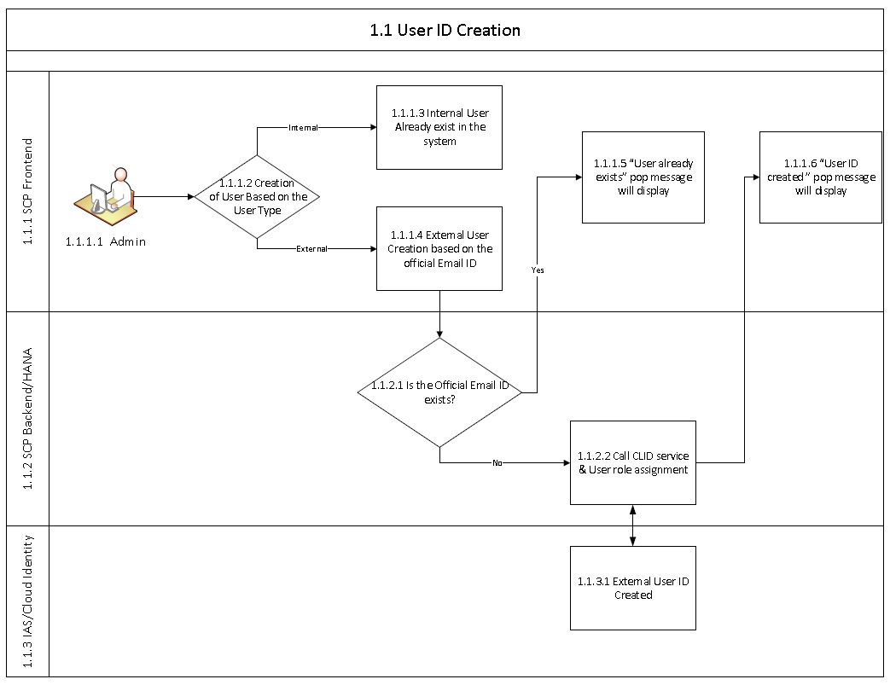

1. User flag for deletion

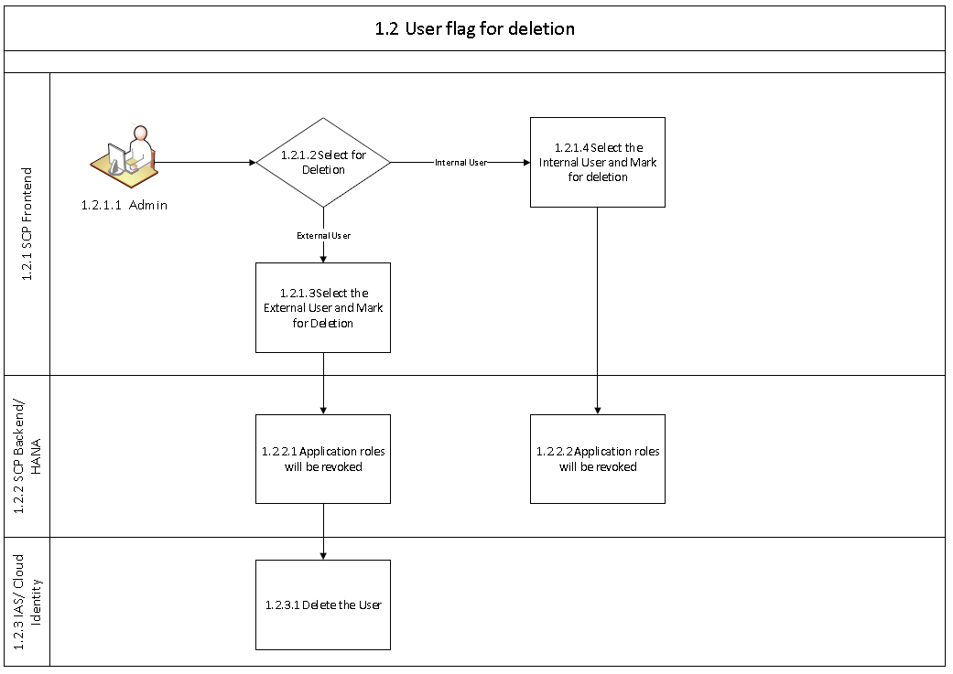

1. **Customer Master Creation in HANA DB-> Enter the Customer number**

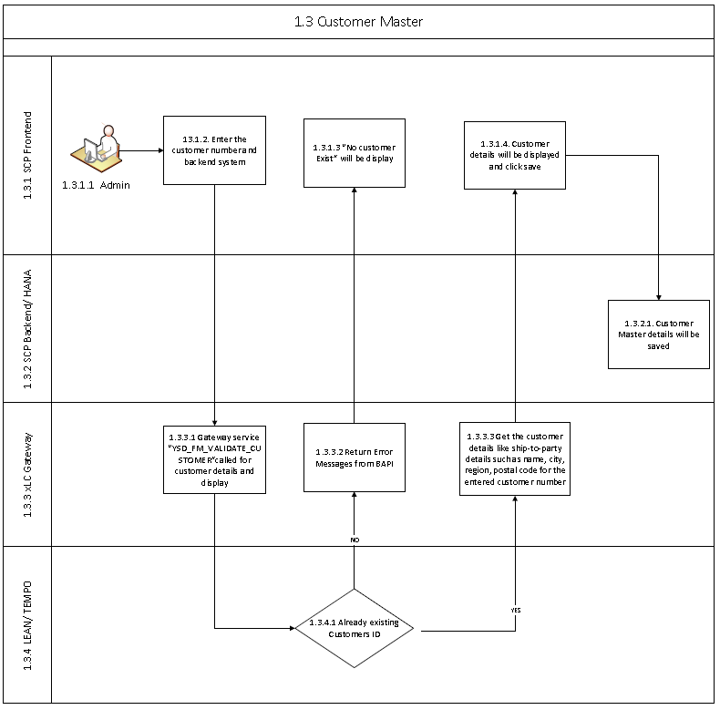

1. **Material Master**

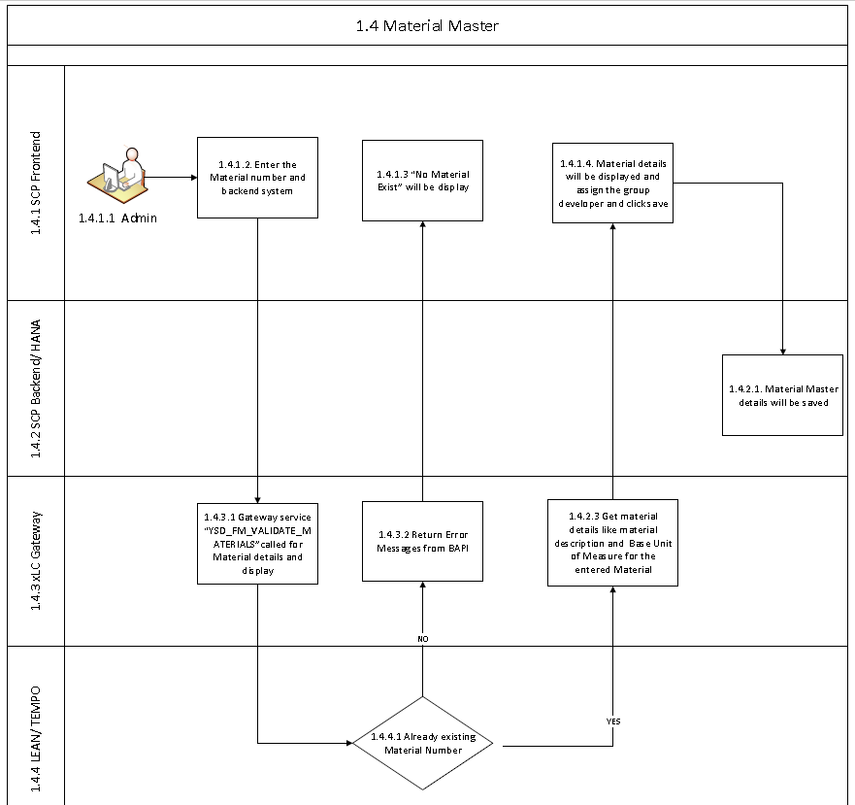

1. **Item Category Master**

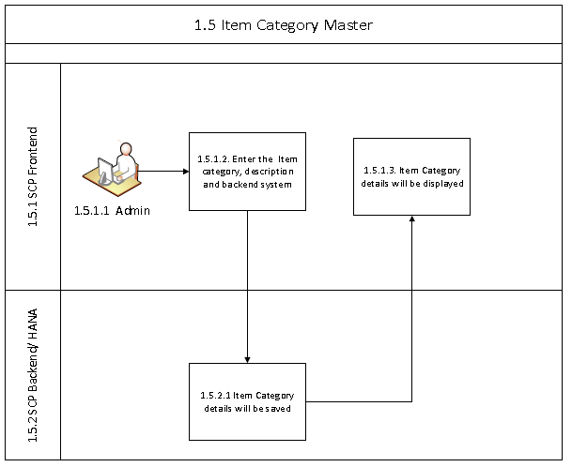

1. **Customer Assignment**

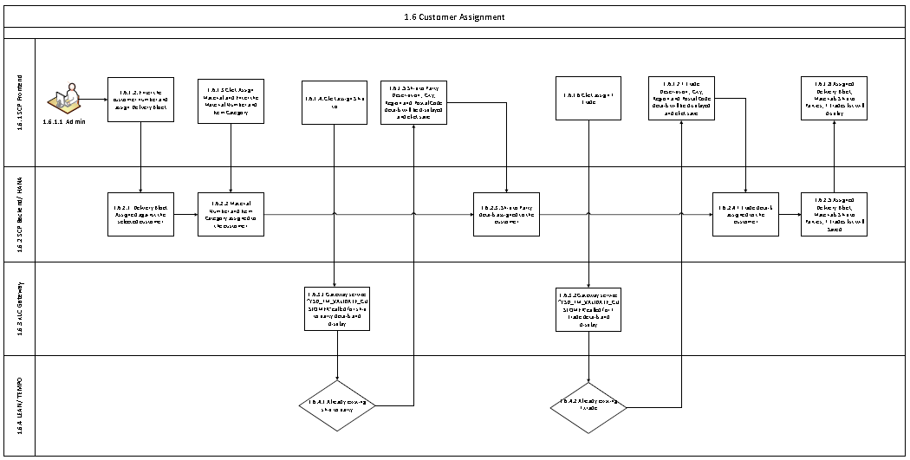

1. **Material Item Category Assignment**

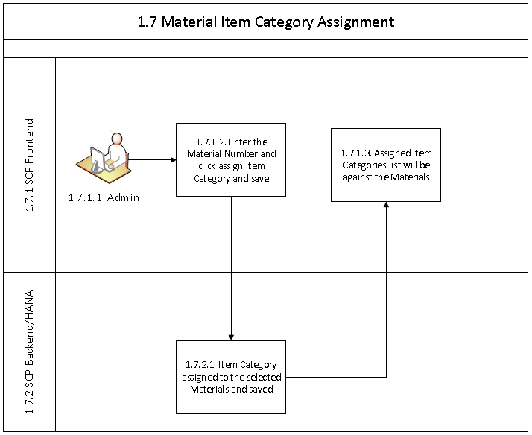

1. **Order Simulation**

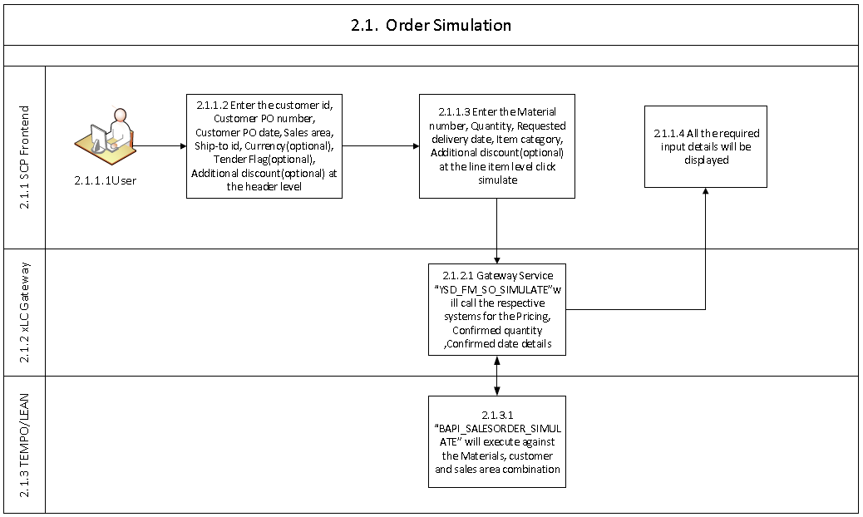

1. **Order Simulation and Creation**

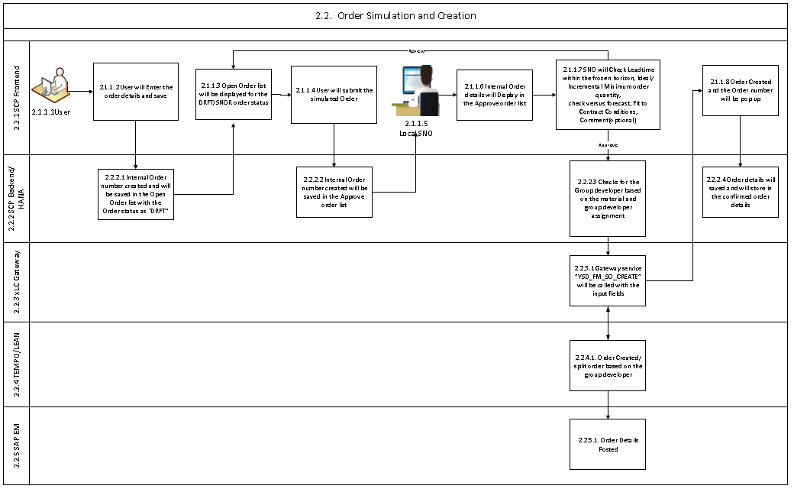

1. **Customer KPI**

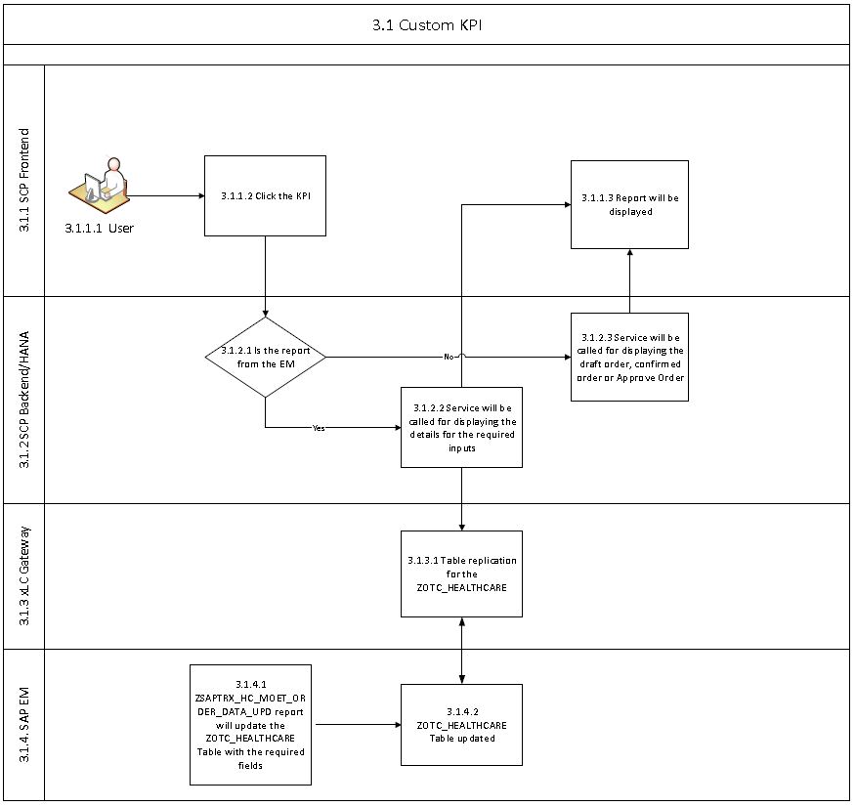

1. Function Calls

This table gives an overview of the used Functions for the read and write operations. The Functions are described in detail in the designed chapters (Gateway, EPR and/or HANA).

|  |  |  |  |  |  |
| --- | --- | --- | --- | --- | --- |
| Operation | | Start | Called System | Type | Function |
| Get Material Details | SCP CC | ALC | **Function Module** YSD_FM_VALIDATE_MATERIALS | This FM is used to check material existence and get Material Description and Base Unit of measure |
| Get Customer Details | SCP CC | ALC | **Function Module**:- YSD_FM_VALIDATE_CUSTOMER | This FM is used to check the customer existence and get customer Details |
| Get Sales area | SCP CC | ALC | **Function Module:-** YSD_FM_SO_GETSALESAREA | This FM is used to get the sales area details for the existing customer |
| Get the minimum orer quantity | SCP CC | ALC | **Function Module:-** YSD_FM_MIN_ORDER_FOR_MATERIAL | This FM is used to get the minimum order quantity for the material |
| Sales Order simulation details | SCP CC | ALC | **Function Module:-** YSD_FM_SO_SIMULATE | This FM is for getting the details after the simulation of the sales order |
| Sales Order creation | SCP CC | ALC | **Function Module:-** YSD_FM_SO_CREATE | This FM is reponsible for the Sales Order creation in the backend system |

1. NAME OF THE OPERATION
2. SAP UI5

The SAPUI Version is the highest maintenance version supported by the SAP Cloud Platform.

The actual Sources of the Project are stored in the Cloud Platform.

* [Folder](https://git.hana.ondemand.com/aa4d355e1/etlm) – MOET_APP

The Link to the App Dashboard is:

* <https://moet-aa4d355e1.dispatcher.hana.ondemand.com/>

The Application SAP Cloud Cockpit Link

* https://account.hana.ondemand.com/cockpit#/acc/aa4d355e1/html5app/moet/dashboard

The used oData Service:

* Hana
  + HANAXS/com/merckgroup/moet/services/odata/moet.xsodata/
* Gateway
  + sap/opu/odata/sap/YSD_MOET_SRV/

The used destinations are:

* **Odata Service**
  + MOET_FE_BA
* **Hana**
  + HANAXS
* **Document Services**
  + /CMIS – To connect Document Service

The details regarding the Destinations are available at the Destination chapter.

* 1. Manifest

|  |  |  |  |
| --- | --- | --- | --- |
| Model | Type | dataSource | dataSource |
| mainService | oData | moet.xsodata | /HANAXS/com/merckgroup/moet/services/odata/moet.xsodata/ |
| MOETSRV | oData | YSD_MOET_SRV | /sap/opu/odata/sap/YSD_MOET_SRV/ |
| annotation | ODataAnnotation | annotation.xml | annotation/annotation.xml |

* 1. App

|  |  |  |
| --- | --- | --- |
| Path | Type | Name |
| /HANAXS | destination | HANAXS |
| / sap/opu/odata | destination | MOET_FE_BA |
|  |  |  |

* 1. Component

1. Get current user data calling standard HANA service: SessionUser
2. SessionUser retrieves current user details.
3. Based on the current user role the menus has to be shown
4. If the user has no access to the application it will show, user doesn’t exist
5. In other case Go to Home.View

1.4 Controllers

1.4.1 HOME.CONTROLLER.JS

|  |  |  |  |
| --- | --- | --- | --- |
| Function | Input | Output | Description |
| GetValue |  |  | To get the counts for the KPI’s in the home page |
| DountChartdisplay |  |  | To create and add donut chart in home page, this function is used |

**GetValue**

1. Call service / OrderStatusCountParam to retrieve the counts of different status of the order and assign it to the respective KPI in the home page
   * 1. APP.CONTROLLER.JS

|  |  |  |  |
| --- | --- | --- | --- |
| Function | Input | Output | Description |
| getUserInfo |  |  | Using the HANA service SessionUser, the user information are retrieved and it is set to the view as Jsonmodel cusInfo |
| onUserNamePress |  |  | Show the user basic information and the link to settings fragment and logout option |
| onSideNavButtonPress |  |  | Function that allow change open or close the side navigation |
| onSettingsClose |  |  | This function closes the settings fragment |
| onCusAssign |  |  | This function fetches the customer assigned for the logged in user using the HANA service UserCustDetails to show in the settings fragment |
| onMaterialAssign |  |  | This function fetches the material details assigned for the logged in user using the HANA service CustomerMatAssignDetails to show in the settings fragment |
| showShiptoPartyValue |  |  | This function fetches the shipto party details assigned for the logged in user using the HANA service CustomerShipToPartyAssignDetails to show in the settings fragment |
| onOpenChatbot |  |  | This function is used to call the getChatbot function and open the chat window at a delayed interval |
| onOpenChatWindow |  |  | This function is used to trigger the chat for enter keypress |
| _getChatbot |  |  | This function opens the chatbot fragment |
| onChatbotClose |  |  | This function is used to close the chatbot fragment |
| onPostMessage |  |  | This function is used to post the message enterd by the user |
| _getBotResponse |  |  | This function is used to get the response for the user input and show it in the chatbot fragment. If the answer is not found in questionnaire and it it is a number then the OrderHeaderDetails HANA service is called to fetch the order service by using the Filter("ZINTR_ORDNUM", "EQ", prdId). If the order number matches then it is navigated to the respective order detail page. If the order number does not match then it replies with “Can you please provide valid Internal Order Number” |
| _addChatItem |  | Text: “text”,  Author: "ChatBot",  styleClass: "cls_feedlInputList_Position",  Date: new Date() | This function is used to push the chat text to the feedinput box in the chatbot fragment using the model push |
| deleteChatHistory |  |  | This function clears the data in the chat fragment |
| _getUserDetails |  |  | This function is used by the chat to get the user information and check whether the logged in user has the rights to see the order, based on the role of the user. If the role does not allow then the bot responses as “Sorry you are not authorised to see this Order” |
| handlingUseractions |  |  | This function is used to check which button is clicked in the chatbot fragment and make the call based on that |
| onStartRecording |  |  | This function is used to record the user voice and make it as text for the chat searchss |

**questionnaire.json**

1. This is the json file which is used in the chatbot to fetch the questions and respective answers
   * 1. USERMAINTENANCE.CONTROLLER.JS

|  |  |  |  |
| --- | --- | --- | --- |
| Function | Input | Output | Description |
| onSave | payload = { ZUSR_ID: uid, ZUSR_NAME: uname, ZUSR_TYP: utype, ZUSR_ROLE: urole, ZUSR_EMAILADD: uemail, ZUSR_STATUS: ustatus, OLDROLE: "" } |  | This function is used to save the user information into the user table through the HANA service user.xsjs |
| _onUpdateUser | payload = { "ZUSR_ID": Uid , "ZUSR_ROLE":UserType, "ZUSR_STATUS": Status, OLDROLE: OldRole  }; |  | This function is used to update the user information into the user table through the HANA service user.xsjs |
| onDeletePress | payload = {  "ZUSR_ID": Uid,  "OLDROLE": Urole  } |  | This function is used to delete the user information from the user table through the HANA service user.xsjs |
| onSaveAssignCustomer | payload = [{ ZUSR_ID: UserId, ZCUST_NUM: CustomerNo,  ZSYSTEM: System,  ZCOMMENTS: Comment,  ZCUST_STATUS: Status  }] |  | This function is used to add a customer to the user with the HANA service userCustAssign.xsjs |
| _onDeleteCustAssign | payload = { "ZUSR_ID": UserId, "ZCUST_NUM": CustomerNo  } |  | This function is used to delete the customer from the user ssthrough the HANA service userCustAssign.xsjs |
| _onUpdateCustAssign | {  "ZUSR_ID": UserId,  "ZCUST_NUM": CustomerNo,  "ZCOMMENTS": Comment,  "ZCUST_STATUS": Status  } |  | This function is used to eidt a customer assigned to the user with the HANA service userCustAssign.xsjs |

* + 1. CUSTOMERMASTER.CONTROLLER.JS

|  |  |  |  |
| --- | --- | --- | --- |
| Function | Input | Output | Description |
| onSaveCustomermaster | payload = {  ZCUSTMR_NUM: CustomerNo,  ZSYSTEM: System,  ZNAME_1: Name,  ZCITY: City,  ZREGION: Region,  ZCENTRL_DEL_FLAG: Flag,  ZPOSTAL_CODE: Postal Code,  ZDEL_BLOCK_ID: DeliveryBlockId  }; |  | This function is used to save the customer information into the customer table through the HANA service customerMasterCRUD |
| onDeleteCustPress | payload = { ZCUSTMR_NUM: sCumId } |  | This function is used to delete a customer information from the customer table through the HANA service customerMasterCRUD |
| onEditCust | payload = {  ZCUSTMR_NUM: CustomerNo,  ZSYSTEM: System,  ZNAME_1: Name,  ZCITY: City,  ZREGION: Region,  ZCENTRL_DEL_FLAG: Flag,  ZPOSTAL_CODE: Postal Code,  ZDEL_BLOCK_ID: DeliveryBlockId  }; |  | This function is used to edit the customer information in the customer table through the HANA service customerMasterCRUD |
| onSaveMatAssign | payload = {  ZCUST_NUM: CustNo,  ZMAT_NUM: MatNo,  ZSYSTEM: System,  ZSALES_ORG: SalesArea,  ZDISTR_CHNL: DChannel,  ZDIVISION: Division,  ZCURR: Currency,  ZDEL_FLAG: FLAG  } |  | This function is used to save the customer material assignment with the HANA service custMatAssign |
| onUpdateMatAssignment | payload = {  ZCUST_NUM: CustNo,  ZMAT_NUM: MatNo,  ZSYSTEM: System,  ZSALES_ORG: SalesArea,  ZDISTR_CHNL: DChannel,  ZDIVISION: Division,  ZCURR: Currency,  ZDEL_FLAG: FLAG  } |  | This function is used to edit the Material information assigned for a customer with the HANA service custMatAssign |
| _onDeleteMatAssign | Payload={ "ZCUST_NUM": CustNo, "ZMAT_NUM": MatNo |  | This function is used to delete a material which has been assigned for a customer with the HANA service custMatAssign |
| onSaveCMItemToMaterial | payload = {  ZCUST_NUM: CustNo,  ZMAT_NUM: MatNo,  ZITM_CATEGORY: ItmCat,  ZSYSTEM: System,  ZDEL_FLAG: Flag  } |  | This function is used to assign an Item Category for a material which is assigned for a customer with the HANA service custMatItemCategory |
| onDeleteCMItemAssign | payload = {  "ZCUST_NUM": CustNo,  "ZMAT_NUM": MatNo,  "ZITM_CATEGORY": ItemCat  } |  | This function is used to delete an Item Category from a material which is assigned for a customer with the HANA service custMatItemCategory |
| onSaveBlockmaster | payload = {  ZCUST_NUM: CustNo,  ZDEL_BLOCK_ID: DelBlockId,  ZLANGUAGE: Lang,  ZDEL_BLOCK_DESC: BlockDesc  } |  | This function is used to assign a delivery Block to a customer using the HANA service custDeliveryBlock |
| _onUpdateBlockAssign | payload = { "ZCUST_NUM": aData.ZCUST_NUM, "ZDEL_BLOCK_ID": aData.ZDEL_BLOCK_ID  } |  | This function is used to delete a delivery Block which is assigned for a customer using the HANA service custDeliveryBlock |
| onSaveShiptomaster | payload = {  ZCUSTMR_NUM: CustNo,  ZSHIP_TO_PARTY: Shipto,  ZSHIP_TO_PARTY_DESC: ShiptoDesc,  ZCITY: ShiptoCity,  ZREGION: ShiptoReg,  ZPOSTAL_CODE: ShiptoPo,  ZDEL_FLAG: Flag  } |  | This function is used to assign a Shipto for a customer using the HANA service custShiptoPartyAssign |
| _onUpdateShipAssign | payload = {  "ZCUSTMR_NUM": CustNo,  "ZSHIP_TO_PARTY": ShipTO  } |  | This function is used to delete a ShipTo which is assigned for a customer using the HANA service custShiptoPartyAssign |
| onSaveFtrademaster | payload = {  ZCUST_NUM: sCustNo,  ZFTRADE: sFtrade,  ZFTRADE_DESC: sFtradeDesc,  ZCITY: sFtradeCity,  ZREGION: sFtradeReg,  ZPOSTAL_CODE: sFtradePo  } |  | This function is used to assign a Foreign Trade Value for a customer using the HANA service custForeignTrade |
| _onUpdateFtradeAssign | payload = {  "ZCUST_NUM": aData.ZCUST_NUM,  "ZFTRADE": aData.ZFTRADE  } |  | This function is used to delete a Foreign Trade Value which is assigned for a customer using the HANAss service custForeignTrade |

* + 1. MATERIALMASTER.CONTROLLER.JS

|  |  |  |  |
| --- | --- | --- | --- |
| Function | Input | Output | Description |
| onSaveMaterialmaster | Payload={ Z_MATRL_NUM: MatNo,  ZSYSTEM: SystemId,  ZMATRL_DESC: MatDesc,  ZBASE_UNIT_MEASURE: Unit,  ZMIN_ORDER_QUAN: MinOrderQuantity,  ZGRP_DEVLPR: GroupDeveloper,  ZDEL_FLAG: Flag} |  | This function is used to save the material information with the HANA service materialMaster |
| onDeleteMatPress | payload = {  Z_MATRL_NUM: sMatId  } |  | This function is used to delete the material information from the table with the HANA service materialMaster |
| onSaveItemToMaterial | payload = {  ZMAT_NUM: MatNo,  ZITM_CATEGORY: ItmCat,  ZSYSTEM: System,  ZDEL_FLAG: Flag  } |  | This function is used to assign an Item Category for the Material using the HANA service matItemCategoryAssign |
| onDeleteMaterialAssign | payload = {  ZMAT_NUM: MatNo,  ZITM_CATEGORY: ItmCat} |  | This function is used to remove an Item Category from the Material using the HANA service matItemCategoryAssign |

* + 1. ITEMCATEGORY.CONTROLLER.JS

|  |  |  |  |
| --- | --- | --- | --- |
| Function | Input | Output | Description |
| onSaveItemMaster | payload = {  ZITM_CATEGORY: ItemCat,  ZSYSTEM: System,  ZITM_CATEGORY_DESC: ItemCatDesc,  ZDEL_FLAG: Flag  } |  | This function is used to save Item Category data to the table using the HANA service itemCategory |
| onUpdateItmSavePress | payload = {  ZITM_CATEGORY: ItemCat,  ZSYSTEM: System,  ZITM_CATEGORY_DESC: ItemCatDesc,  ZDEL_FLAG: Flag  } |  | This function is used to update Item Category data to the table using the HANA service itemCategory |

* + 1. AUDITTRAIL.CONTROLLER.JS

|  |  |  |  |
| --- | --- | --- | --- |
| Function | Input | Output | Description |
| onSectionCahnges |  |  | This function is used to trigger each of the tabs for each audit trial report and the table of data is displayed |

* + 1. Orders.controller.JS

|  |  |  |  |
| --- | --- | --- | --- |
| Function | Input | Output | Description |
| onUpdateOrder |  |  | This function is used to update the order data using the HANA services order.xsjs |
| showSalesOffice |  |  | This function is used to fetch the Sales Office details of a customer using the Odata gateway service ysaleAreaInputSet |
| soLineShow |  |  | This function is used to fetch the Shedule Line details of an item using the Odata gateway service ysoschedulelinesSet |
| getPallet |  |  | This function is used to fetch the pallet quantity of an item using the Odata gateway service yminorderInputSet |
| onSimulate |  |  | This function is used to simulate the order data using the Odata gateway service ysalesordersimulationInputSet |

* + 1. ApproveOrders.controller.JS

|  |  |  |  |
| --- | --- | --- | --- |
| Function | Input | Output | Description |
| onAppr |  |  | This function is used to approve and create the order in SAP system using the Odata gateway service YSOCREATEinputSet and then if the order is saved correctly in SAP system then the order is saved/updated in the HANA system with the status ORCR using the service order.xsjs |
| onReview |  |  | This function is used to review/reject the order and is saved/updated in the HANA system with the status SNOR using the service order.xsjs |

* + 1. ProcessOrders.controller.JS

|  |  |  |  |
| --- | --- | --- | --- |
| Function | Input | Output | Description |
| onAddCM1Press |  |  | This function is used to fetch the order header and item details and show the same in confirmedOrders fragment |

* + 1. OrderReport.controller.JS

|  |  |  |  |
| --- | --- | --- | --- |
| Function | Input | Output | Description |
|  |  |  |  |

The report is directly binded with the HANA service OTCHealthCareReport to fetch the SLT data of the orders

* + 1. NewOrder.controller.JS

|  |  |  |  |
| --- | --- | --- | --- |
| Function | Input | Output | Description |
| onSimulateSubmit |  |  | This function is used to review/reject the order and is saved/updated in the HANA system with the status SNOA using the service order.xsjs |
| onSave |  |  | This function is used to review/reject the order and is saved/updated in the HANA system with the status DRFT using the service order.xsjs |
| onSimulatePress |  |  | This function is used to simulate the order data using the Odata gateway service ysalesordersimulationInputSet |
| soLineShow |  |  | This function is used to fetch the Shedule Line details of an item using the Odata gateway service ysoschedulelinesSet |
| getPallet |  |  | This function is used to fetch the pallet quantity of an item using the Odata gateway service yminorderInputSet |

**formatter.js**

**dateFormat**

This function is used to format the date in dd-MM-yyyy format

**dateFormatWithTime**

This function is used to format the date time value in dd-MM-yyyy format

* 1. Document Services

Development

|  |  |  |  |  |
| --- | --- | --- | --- | --- |
| Repo Name | Repo Password | Folder Name | Folder Id | JAVA App Name |
| com.merck.uxrepo | NA | MOET_Repo_Folder | cYsP2tOQ5fa15OTmAtVf-RhjT_geIDnJRJ3VE9WIThg | cmis |

Quality

|  |  |  |  |  |
| --- | --- | --- | --- | --- |
| Repo Name | Repo Password | Folder Name | Folder Id | JAVA App Name |
| com.merckgroup | NA | MOET_Repo_Folder | sWrYJclf44vYnGYTGCtlQE_F0iQiYkr2hVhw0utMKqs | cmis |

Production

|  |  |  |  |  |
| --- | --- | --- | --- | --- |
| Repo Name | Repo Password | Folder Name | Folder Id | JAVA App Name |
| com.merckgroup | NA | MOET_Repo_Folder | OdM8nQONL8vvafFcroZq_t0hdKg66be0UYVshrJDAvM | cmis |

|  |  |
| --- | --- |
| Repository Name | com.merckgroup.cmis |
| Java Application | cmis |
| Folder Id (UAT) | sWrYJclf44vYnGYTGCtlQE_F0iQiYkr2hVhw0utMKqs |
| Upload Document | /CMIS/cmis/upload |
| Download Document | /CMIS/cmis/download?docId=xxxx |
| Delete Document | /CMIS/cmis/delete?docId=xxxx |

1. SCP Backend-HANA

Global Packages

1.com.merckgroup.glog.logic.crud

2.com.merckgroup.util

3.com.merckgroup.usad.logic

4.com.merckgroup.clid.logic.crud

* 1. Display, Create, Update, Delete User

**User Display Service**

<https://moet-aa4d355e1.dispatcher.hana.ondemand.com/HANAXS/com/merckgroup/moet/services/odata/moet.xsodata/UserDetails>

**User Create**

|  |  |
| --- | --- |
| Tables | ZUSER, ZUSER_MAINTENANCE_LOG |
| Action | Create User |
| Odata URL | NA |
| InputParams | N/A |
| Method | POST |
| Entity Name |  |
| XSJS URL | <https://jx4aa4d355e1.hana.ondemand.com/com/merckgroup/moet/services/xsjs/user.xsjs> |
| xsjslib | NA |
| HBD Procedure | "MOET"." com.merckgroup.moet.logic.crud::createUser" |
| Model Name | NA |
| JSON Body | {  "ZUSR_ID": "SHHAFIJ1",  "ZUSR_NAME": "Test",  "ZUSR_TYP": "I",  "ZUSR_ROLE": "ADMIN",  "ZUSR_EMAILADD": "test@MERCKGROUP.COM",  "ZUSR_STATUS": "ACTV",  "OLDROLE" : ""  } |
|  |  |

Method: POST

**User Update**

**Method: PUT**

|  |  |
| --- | --- |
| Tables | ZUSER, ZUSER_MAINTENANCE_LOG |
| Action | Update User |
| Odata URL | NA |
| InputParams | N/A |
| Method | PUT |
| Entity Name |  |
| XSJS URL | <https://jx4aa4d355e1.hana.ondemand.com/com/merckgroup/moet/services/xsjs/user.xsjs> |
| xsjslib | NA |
| HBD Procedure | "MOET"." com.merckgroup.moet.logic.crud::updateUser" |
| Model Name | NA |
| JSON Body | { "ZUSR_ID": "SHHAFIJ1",  "ZUSR_ROLE": "CUST",  "ZUSR_STATUS": "BLKD",  "OLDROLE" : "ADMIN"  } |
|  |  |

User Delete

Method: DELETE

|  |  |
| --- | --- |
| Tables | ZUSER, ZUSER_MAINTENANCE_LOG |
| Action | Delete User |
| Odata URL | NA |
| InputParams | N/A |
| Method | DELETE |
| Entity Name |  |
| XSJS URL | <https://jx4aa4d355e1.hana.ondemand.com/com/merckgroup/moet/services/xsjs/user.xsjs> |
| xsjslib | NA |
| HBD Procedure | "MOET"." com.merckgroup.moet.logic.crud::updateUser" |
| Model Name | NA |
| JSON Body | {  "ZUSR_ID": "SHHAFIJ",  "OLDROLE" : "ADMIN"  } |
|  |  |

* 1. Display, Create, Update, Delete User Customer Assignment

**User Customer Assignment Display Service**

<https://moet-aa4d355e1.dispatcher.hana.ondemand.com/HANAXS/com/merckgroup/moet/services/odata/moet.xsodata/UserCustAssignDetails>

**mo**

**User Customer Assignment Create**

|  |  |
| --- | --- |
| Tables | ZUSER_CUSTMR_ASGN, ZUSER_CUST_ASGN_LOG |
| Action | Create User Customer Assignment |
| Odata URL | NA |
| InputParams | N/A |
| Method | POST |
| Entity Name |  |
| XSJS URL | <https://jx4aa4d355e1.hana.ondemand.com/com/merckgroup/moet/services/xsjs/userCustAssign.xsjs> |
| xsjslib | NA |
| HBD Procedure | "MOET"." com.merckgroup.moet.logic.crud:: createUserCustomerAssign" |
| Model Name | NA |
| JSON Body | [{  "ZUSR_ID" : "SSHAFFIJ",  "ZCUST_NUM": "C008",  "ZSYSTEM": "L",  "ZCOMMENTS": "TESTING USER ASSIGNMENT",  "ZCUST_STATUS" : "ACTV"  }] |
|  |  |

**User Customer Assignment Update**

|  |  |
| --- | --- |
| Tables | ZUSER_CUSTMR_ASGN, ZUSER_CUST_ASGN_LOG |
| Action | Update User Customer Assignment |
| Odata URL | NA |
| InputParams | N/A |
| Method | PUT |
| Entity Name |  |
| XSJS URL | <https://jx4aa4d355e1.hana.ondemand.com/com/merckgroup/moet/services/xsjs/userCustAssign.xsjs> |
| xsjslib | NA |
| HBD Procedure | "MOET"." com.merckgroup.moet.logic.crud:: updateUserCutomerAssign" |
| Model Name | NA |
| JSON Body | {  "ZUSR_ID" : "RAM",  "ZCUST_NUM": "C005",  "ZCOMMENTS": "TESTING LOG",  "ZCUST_STATUS" : "ACTV"  } |
|  |  |

**User Customer Assignment Delete**

|  |  |
| --- | --- |
| Tables | ZUSER_CUSTMR_ASGN, ZUSER_CUST_ASGN_LOG |
| Action | Delete User Customer Assignment |
| Odata URL | NA |
| InputParams | N/A |
| Method | DELETE |
| Entity Name |  |
| XSJS URL | <https://jx4aa4d355e1.hana.ondemand.com/com/merckgroup/moet/services/xsjs/userCustAssign.xsjs> |
| xsjslib | NA |
| HBD Procedure | "MOET"." com.merckgroup.moet.logic.crud deleteUserCustomerAssign" |
| Model Name | NA |
| JSON Body | {  "ZUSR_ID" : "VBIRADHA",  "ZCUST_NUM": "1114"  } |
|  |  |

* 1. Display, Create, Update, Delete Customer

**Customer Master Display**

<https://moet-aa4d355e1.dispatcher.hana.ondemand.com/HANAXS/com/merckgroup/moet/services/odata/moet.xsodata/CustomerDetails>

**Customer Master Create**

|  |  |
| --- | --- |
| Tables | ZCUSTMR_MASTR,ZCUSTOMER_MASTER_MAINT_LOG |
| Action | Create Customer |
| Odata URL | NA |
| InputParams | N/A |
| Method | POST |
| Entity Name |  |
| XSJS URL | https://jx4aa4d355e1.hana.ondemand.com/com/merckgroup/moet/services/xsjs/customerMasterCRUD.xsjs |
| xsjslib | NA |
| HBD Procedure | "MOET"." com.merckgroup.moet.logic.crud::createCustomer" |
| Model Name | NA |
| JSON Body | {  "ZCUSTMR_NUM" : "210101812",  "ZSYSTEM" :"L",  "ZNAME_1" : "RAJU",  "ZCITY" : "BANGLORE",  "ZREGION" : "S",  "ZCENTRL_DEL_FLAG" : "",  "ZPOSTAL_CODE" : "5601",  "ZDEL_BLOCK_ID" : "01"    }  ss |
|  |  |

**Customer Master Update**

|  |  |
| --- | --- |
| Tables | ZCUSTMR_MASTR,ZCUSTOMER_MASTER_MAINT_LOG |
| Action | Update Customer |
| Odata URL | NA |
| InputParams | N/A |
| Method | PUT |
| Entity Name |  |
| XSJS URL | https://jx4aa4d355e1.hana.ondemand.com/com/merckgroup/moet/services/xsjs/customerMasterCRUD.xsjs |
| xsjslib | NA |
| HBD Procedure | "MOET"." com.merckgroup.moet.logic.crud::updateCustomer" |
| Model Name | NA |
| JSON Body | {  "ZCUSTMR_NUM" : "2011",  "ZSYSTEM" :"L",  "ZNAME_1" : "RAJU CHECK",  "ZCITY" : "BANGLORE",  "ZREGION" : "S",  "ZCENTRL_DEL_FLAG" : "",  "ZPOSTAL_CODE" : "5601",  "ZDEL_BLOCK_ID" : "04"    } |
|  |  |

**Customer Master DELETE**

|  |  |
| --- | --- |
| Tables | ZCUSTMR_MASTR,ZCUSTOMER_MASTER_MAINT_LOG |
| Action | Delete Customer |
| Odata URL | NA |
| InputParams | N/A |
| Method | DELETE |
| Entity Name |  |
| XSJS URL | https://jx4aa4d355e1.hana.ondemand.com/com/merckgroup/moet/services/xsjs/customerMasterCRUD.xsjs |
| xsjslib | NA |
| HBD Procedure | "MOET"." com.merckgroup.moet.logic.crud::deleteteCustomer" |
| Model Name | NA |
| JSON Body | {  "ZCUSTMR_NUM" : "2011"  } |
|  |  |

* 1. Display, Create, Update, Delete Customer Material Assignment

**Customer Material Assignment Display**

<https://moet-aa4d355e1.dispatcher.hana.ondemand.com/HANAXS/com/merckgroup/moet/services/odata/moet.xsodata/CustomerMatAssignDetails>

**Customer Material Assignment Create**

|  |  |
| --- | --- |
| Tables | ZCUSTMR_MATRL_ASGN, ZCUST_MAT_ASGN_LOG |
| Action | Create Customer Material Assignment |
| Odata URL | NA |
| InputParams | N/A |
| Method | POST |
| Entity Name |  |
| XSJS URL | <https://jx4aa4d355e1.hana.ondemand.com/com/merckgroup/moet/services/xsjs/custMatAssign.xsjs> |
| xsjslib | NA |
| HBD Procedure | "MOET"." com.merckgroup.moet.logic.crud:: createCustMatrlAssign" |
| Model Name | NA |
| JSON Body | {  "ZCUST_NUM" : "2011",  "ZMAT_NUM" : "ES01-FERT",  "ZSYSTEM" : "L",  "ZSALES_ORG": "ES51",  "ZDISTR_CHNL": "41",  "ZDIVISION" : "00",  "ZDEL_FLAG" : ""  } |
|  |  |

**Customer Material Assignment Delete**

|  |  |
| --- | --- |
| Tables | ZCUSTMR_MATRL_ASGN, ZCUST_MAT_ASGN_LOG |
| Action | Delete Customer Material Assignment |
| Odata URL | NA |
| InputParams | N/A |
| Method | DELETE |
| Entity Name |  |
| XSJS URL | <https://jx4aa4d355e1.hana.ondemand.com/com/merckgroup/moet/services/xsjs/custMatAssign.xsjs> |
| xsjslib | NA |
| HBD Procedure | "MOET"." com.merckgroup.moet.logic.crud:: createCustMatrlAssign" |
| Model Name | NA |
| JSON Body | {  "ZCUST_NUM" : "2011",  "ZMAT_NUM" : "ES01-FERT"    } |
|  |  |

* 1. Display, Create, Update, Delete Customer Ship to Party Assignment

**Customer Ship to Party Assignment Display**

<https://moet-aa4d355e1.dispatcher.hana.ondemand.com/HANAXS/com/merckgroup/moet/services/odata/moet.xsodata/CustomerShipToPartyAssignDetails>

**Customer Ship to Party Assignment Create**

|  |  |
| --- | --- |
| Tables | ZCUST_SHIP_TO_PARTY, ZCUST_SHIPTO_ASGN_LOG |
| Action | Create Customer Ship to Party Assignment |
| Odata URL | NA |
| InputParams | N/A |
| Method | POST |
| Entity Name |  |
| XSJS URL | <https://jx4aa4d355e1.hana.ondemand.com/com/merckgroup/moet/services/xsjs/custShiptoPartyAssign.xsjs> |
| xsjslib | NA |
| HBD Procedure | "MOET"." com.merckgroup.moet.logic.crud:: createCustShipToParty" |
| Model Name | NA |
| JSON Body | {  "ZCUSTMR_NUM" : "2011",  "ZSHIP_TO_PARTY": "210100806",  "ZSHIP_TO_PARTY_DESC" : "APO CINDY NACHTERGALE BVBA",  "ZCITY" : "Singapore",  "ZREGION": "SG",  "ZPOSTAL_CODE" : "639798" ,  "ZDEL_FLAG" : ""  } |
|  |  |

**Customer Ship to Party Assignment Update**

|  |  |
| --- | --- |
| Tables | ZCUST_SHIP_TO_PARTY,ZCUST_SHIPTO_ASGN_LOG |
| Action | Update Customer Ship to Party Assignment |
| Odata URL | NA |
| InputParams | N/A |
| Method | PUT |
| Entity Name |  |
| XSJS URL | <https://jx4aa4d355e1.hana.ondemand.com/com/merckgroup/moet/services/xsjs/custShiptoPartyAssign.xsjs> |
| xsjslib | NA |
| HBD Procedure | "MOET"." com.merckgroup.moet.logic.crud:: updateCustShipToParty" |
| Model Name | NA |
| JSON Body | {  "ZCUSTMR_NUM" : "2035519185",  "ZSHIP_TO_PARTY": "2035519185",  "ZSHIP_TO_PARTY_DESC" : "TEST UPDATE ",  "ZCITY" : "Singapore",  "ZREGION": "SG",  "ZPOSTAL_CODE" : "639798",  "ZDEL_FLAG" : ""  } |
|  |  |

**Customer Ship to Party Assignment Delete**

|  |  |
| --- | --- |
| Tables | ZCUST_SHIP_TO_PARTY,ZCUST_SHIPTO_ASGN_LOG |
| Action | Delete Customer Ship to Party Assignment |
| Odata URL | NA |
| InputParams | N/A |
| Method | DELETE |
| Entity Name |  |
| XSJS URL | <https://jx4aa4d355e1.hana.ondemand.com/com/merckgroup/moet/services/xsjs/custShiptoPartyAssign.xsjs> |
| xsjslib | NA |
| HBD Procedure | "MOET"." com.merckgroup.moet.logic.crud:: deleteCustShipToParty" |
| Model Name | NA |
| JSON Body | {  "ZCUSTMR_NUM" : "2011",  "ZSHIP_TO_PARTY": "210100806"  } |
|  |  |

2.6 Display, Create, Update, Delete Customer FTRADE Assignment

**Customer FTRADE Assignment Display**

<https://moet-aa4d355e1.dispatcher.hana.ondemand.com/HANAXS/com/merckgroup/moet/services/odata/moet.xsodata/CustomerFTradeAssignDetails>

**Customer FTRADE Assignment Create**

|  |  |
| --- | --- |
| Tables | ZCUST_FTRADE,ZCUST_FTRADE_ASGN_LOG |
| Action | Create Customer FTRADE Assignment |
| Odata URL | NA |
| InputParams | N/A |
| Method | POST |
| Entity Name |  |
| XSJS URL | <https://jx4aa4d355e1.hana.ondemand.com/com/merckgroup/moet/services/xsjs/custForeignTrade.xsjs> |
| xsjslib | NA |
| HBD Procedure | "MOET"." com.merckgroup.moet.logic.crud:: createCustForeignTrade" |
| Model Name | NA |
| JSON Body | {  "ZCUST_NUM": "2011",  "ZFTRADE" : "2003000375",  "ZFTRADE_DESC" : "SHANKAR",  "ZCITY" : "Hyderabad",  "ZREGION" : "GB",  "ZPOSTAL_CODE" : "560041",  "ZDEL_FLAG" : ""  } |
|  |  |

**Customer FTRADE Assignment Delete**

|  |  |
| --- | --- |
| Tables | ZCUST_FTRADE, ZCUST_FTRADE_ASGN_LOG |
| Action | Delete Customer FTRADE Assignment |
| Odata URL | NA |
| InputParams | N/A |
| Method | DELETE |
| Entity Name |  |
| XSJS URL | <https://jx4aa4d355e1.hana.ondemand.com/com/merckgroup/moet/services/xsjs/custForeignTrade.xsjs> |
| xsjslib | NA |
| HBD Procedure | "MOET"." com.merckgroup.moet.logic.crud:: deleteCustForeignTrade" |
| Model Name | NA |
| JSON Body | {  "ZCUST_NUM" : "2011",  "ZFTRADE" : "2003000375"  } |
|  |  |

2.7 Display, Create, Update, Delete Material Master Create

**Material Master Display**

<https://moet-aa4d355e1.dispatcher.hana.ondemand.com/HANAXS/com/merckgroup/moet/services/odata/moet.xsodata/MaterialDetails>

**Material Master Create**

|  |  |
| --- | --- |
| Tables | ZMATRL_MASTER, ZMAT_MASTER_MAINT_LOG |
| Action | Create Material Master |
| Odata URL | NA |
| InputParams | N/A |
| Method | POST |
| Entity Name |  |
| XSJS URL | <https://jx4aa4d355e1.hana.ondemand.com/com/merckgroup/moet/services/xsjs/materialMaster.xsjs> |
| xsjslib | NA |
| HBD Procedure | "MOET"." com.merckgroup.moet.logic.crud:: createMaterial" |
| Model Name | NA |
| JSON Body | {  "Z_MATRL_NUM" : "103",  "ZSYSTEM" : "L",  "ZMATRL_DESC" : "HCL solution",  "ZBASE_UNIT_MEASURE" : "G",  "ZMIN_ORDER_QUAN": "0",  "ZDEL_FLAG" : ""  } |
|  |  |

**Material Master Update**

|  |  |
| --- | --- |
| Tables | ZMATRL_MASTER,ZMAT_MASTER_MAINT_LOG |
| Action | Update Material Master |
| Odata URL | NA |
| InputParams | N/A |
| Method | PUT |
| Entity Name |  |
| XSJS URL | <https://jx4aa4d355e1.hana.ondemand.com/com/merckgroup/moet/services/xsjs/materialMaster.xsjs> |
| xsjslib | NA |
| HBD Procedure | "MOET"." com.merckgroup.moet.logic.crud:: updateMaterial" |
| Model Name | NA |
| JSON Body | {  "Z_MATRL_NUM" : "123334234",  "ZMATRL_DESC" : "Choline hydroxide solution",  "ZBASE_UNIT_MEASURE" : "G",  "ZMIN_ORDER_QUAN": "0",  "ZDEL_FLAG" : "X",  **"REVOKE_FLAG" : "X"**  } |
|  |  |

**Material Master Delete**

|  |  |
| --- | --- |
| Tables | ZMATRL_MASTER, ZMAT_MASTER_MAINT_LOG |
| Action | Delete Material Master |
| Odata URL | NA |
| InputParams | N/A |
| Method | DELETE |
| Entity Name |  |
| XSJS URL | <https://jx4aa4d355e1.hana.ondemand.com/com/merckgroup/moet/services/xsjs/materialMaster.xsjs> |
| xsjslib | NA |
| HBD Procedure | "MOET"." com.merckgroup.moet.logic.crud:: deleteMaterial" |
| Model Name | NA |
| JSON Body | {  "Z_MATRL_NUM" : "123334234" **,**  **"ZSYSTEM" : "L"**  } |
|  |  |

* 1. Display, Create, Update, Delete Material Item Category Assignment

**Material Item Category Assignment Display**

<https://moet-aa4d355e1.dispatcher.hana.ondemand.com/HANAXS/com/merckgroup/moet/services/odata/moet.xsodata/MatItemCategoryAssign>

**Material Item Category Assignment Create**

|  |  |
| --- | --- |
| Tables | ZMAT_ITEM_CATE_ASSIGN, ZMAT_ITMCATEGORY_ASGN_LOG |
| Action | Create Material Item Category Assignment |
| Odata URL | NA |
| InputParams | N/A |
| Method | POST |
| Entity Name |  |
| XSJS URL | <https://jx4aa4d355e1.hana.ondemand.com/com/merckgroup/moet/services/xsjs/matItemCategoryAssign.xsjs> |
| xsjslib | NA |
| HBD Procedure | "MOET"." com.merckgroup.moet.logic.crud:: createMatItemCategoryAssign" |
| Model Name | NA |
| JSON Body | {  "ZMAT_NUM" : "102",  "ZITM_CATEGORY" : "YTA1",  "ZSYSTEM" : "L",  "ZDEL_FLAG": ""  } |
|  |  |

**Material Item Category Assignment Update**

|  |  |
| --- | --- |
| Tables | ZMAT_ITEM_CATE_ASSIGN,ZMAT_ITMCATEGORY_ASGN_LOG |
| Action | Update Material Item Category Assignment |
| Odata URL | NA |
| InputParams | N/A |
| Method | UPDATE |
| Entity Name |  |
| XSJS URL | <https://jx4aa4d355e1.hana.ondemand.com/com/merckgroup/moet/services/xsjs/matItemCategoryAssign.xsjs> |
| xsjslib | NA |
| HBD Procedure | "MOET"." com.merckgroup.moet.logic.crud:: updateMaterialItmCategory" |
| Model Name | NA |
| JSON Body | {  "ZMAT_NUM" : "1221",  "ZITM_CATEGORY" : "YTS1",  "ZSYSTEM" : "L",  “ZDEL_FLAG": "",  **"REVOKE_FLAG": "X"**  } |
|  |  |

**Material Item Category Assignment Delete**

|  |  |
| --- | --- |
| Tables | ZMAT_ITEM_CATE_ASSIGN,ZMAT_ITMCATEGORY_ASGN_LOG |
| Action | Delete Material Item Category Assignment |
| Odata URL | NA |
| InputParams | N/A |
| Method | DELETE |
| Entity Name |  |
| XSJS URL | <https://jx4aa4d355e1.hana.ondemand.com/com/merckgroup/moet/services/xsjs/matItemCategoryAssign.xsjs> |
| xsjslib | NA |
| HBD Procedure | "MOET"." com.merckgroup.moet.logic.crud:: deleteMaterialItmCategory" |
| Model Name | NA |
| JSON Body | {  "ZMAT_NUM": "1221",  "ZITM_CATEGORY": "YTA1",  "ZSYSTEM" : "T"  } |
|  |  |

* 1. Display, Create, Update, Delete Customer Material Item Category Assignment

**Customer Material Item Category Assignment Display**

<https://moet-aa4d355e1.dispatcher.hana.ondemand.com/HANAXS/com/merckgroup/moet/services/odata/moet.xsodata/CustMatItemCategoryAssign>

**Customer Material Item Category Assignment Create**

|  |  |
| --- | --- |
| Tables | ZCUST_MAT_ITM_CATEGORY |
| Action | Create Customer Material Item Category Assignment |
| Odata URL | NA |
| InputParams | N/A |
| Method | POST |
| Entity Name |  |
| XSJS URL | https://jx4aa4d355e1.hana.ondemand.com/com/merckgroup/moet/services/xsjs/custMatItemCategory.xsjs |
| xsjslib | NA |
| HBD Procedure | "MOET"." com.merckgroup.moet.logic.crud:: createCustMatItemCategory " |
| Model Name | NA |
| JSON Body | {    "ZCUST_NUM" : "10000006",  "ZMAT_NUM" : "10035976",  "ZITM_CATEGORY" : "YTA1",  "ZSYSTEM" : "L",  "ZDEL_FLAG" : ""  } |
|  |  |

**Customer Material Item Category Assignment Delete**

|  |  |
| --- | --- |
| Tables | ZCUST_MAT_ITM_CATEGORY |
| Action | Delete Customer Material Item Category Assignment |
| Odata URL | NA |
| InputParams | N/A |
| Method | DELETE |
| Entity Name |  |
| XSJS URL | https://jx4aa4d355e1.hana.ondemand.com/com/merckgroup/moet/services/xsjs/custMatItemCategory.xsjs |
| xsjslib | NA |
| HBD Procedure | "MOET"." com.merckgroup.moet.logic.crud:: deleteCustMatItemCategory " |
| Model Name | NA |
| JSON Body | {  "ZCUST_NUM" : "10000006",  "ZMAT_NUM" : "10035976",  "ZITM_CATEGORY" : "YTA1"  } |
|  |  |

2.10 SNO OTC HEALTHCARE REPORT Display Service

<https://moet-aa4d355e1.dispatcher.hana.ondemand.com/HANAXS/com/merckgroup/moet/services/odata/moet.xsodata/OTCHealthCareReportSNOParam(P_USERID='FHAQ')/Results>

2.11 Orders Display Service

**Order Header to Order Item**

<https://moet-aa4d355e1.dispatcher.hana.ondemand.com/HANAXS/com/merckgroup/moet/services/odata/moet.xsodata/OrderHeaderDetails?$expand=OrderDetails>

**Orders Create,Update**

|  |  |
| --- | --- |
| Tables | ZORDER_HEADER,ZORDER_ITEM,ZORDER_HEADER_LOG,ZORDER_ITEM_LOG,ZSPLIT_ORDER |
| Action | Create/Update Customer Material Item Category Assignment |
| Odata URL | NA |
|  |  |
| InputParams | N/A |
| Method | POST |
| Entity Name |  |
| XSJS URL | https://jx4aa4d355e1.hana.ondemand.com/com/merckgroup/moet/services/xsjs/order.xsjs |
| xsjslib | NA |
| HBD Procedure | "MOET"." com.merckgroup.moet.logic.crud:: deleteCustMatItemCategory " |
| Model Name | NA |
| JSON Body | {  "ZORDER_HEADER": [{  "ZINTR_ORDNUM": "",  "ZSYSTEM": "L",  "ZORD_REF": "X",  "ZCUST_NUM": "210100806",  "ZSHIP_PRTY": "210100139",  "ZPO_TYP": "X",  "ZDISCNT": "20",  "ZCUST_PONUM": "A20",  "ZCUST_PODAT": "2021-01-20",  "ZDOC_ID": "100",  "ZORD_STATUS": "DRFT",  "ZORD_NUM": "",  "ZAPPROVAL_STATUS": "",  "ZLEAD_TIME" : "",  "ZMIN_ORDER_QUAN": "",  "ZORDER_FORECAST": "",  "ZFIT_CONTRACT_COND" : "",  "ZREQ_DELV_DAT": "2021-01-22",  "ZTEDER_FLAG" : "",  "ZSALES_AREA" : "ES51",  "ZTOTAL_AMT" : "000000000020000",  "ZFTRADE" : "210100806",  "ZFTRADE_DESC" : "APO CINDY NACHTERGALE BVBA",  "ZCURR" : "EUR",  "ZHCURR" : "USD",  "ZDISTR_CHNL" : "41",  "ZDIVISION" : "00",  "ZDEL_BLOCK_ID": "01",  "ZORD_APPROVAL_STATUS": "",  "ZCOMMENTS": ""  }],  "ZORDER_ITEM": [  {  "ZINTR_ORDNUM": "",  "ZSYSTEM": "L",  "ZINTR_ITEMNUM": "1",  "ZMAT_NUM": "ES01-FERT",  "ZTRGT_QTY": "2",  "ZTRGT_QTYUOM": "EA",  "ZALT_UOM": "EA",  "ZREQ_DLVRYDAT": "2021-01-27",  "ZMIN_QTY" : "0.000",  "ZFOC_SMPL": "YTA1",  "ZORD_NUM": "1220",  "ZITEM_NUM": "10",  "ZDISCNT": "20",  "ZCOST" : "000000000020000",  "ZGRP_DEVLPR": "Merck Sat"  } ,  {  "ZINTR_ORDNUM": "",  "ZSYSTEM": "L",  "ZINTR_ITEMNUM": "2",  "ZMAT_NUM": "3000420221",  "ZTRGT_QTY": "2",  "ZTRGT_QTYUOM": "EA",  "ZALT_UOM": "EA",  "ZREQ_DLVRYDAT": "2021-01-27",  "ZMIN_QTY" : "0.000",  "ZFOC_SMPL": "YTA1",  "ZORD_NUM": "520",  "ZITEM_NUM": "10",  "ZDISCNT": "20",  "ZCOST" : "000000000020000" ,  "ZGRP_DEVLPR": "KGeA"  }  ]  } |
|  |  |

1. Gateway Services:
   1. Design Summary

Healthcare Order Management Tool will have help business to manage the order to cash processes. The application will have two separate tile named Sales order header tracking and Sales order item tracking. The Sales order header tracking tile will display sales order header details. The Sales order item tracking tile will display sales order item, shipment, Invoicing and payment details. There will be summary and labels tile to **d**isplay and navigate into cumulative number of both sales order header and sale order item record based on their statuses.

Functionalities of Sales Order Header Tracking Tool:

* Predefined and user definable status labels.
* Adapt filter with smart search.
* Quick view for order highlights and statuses.
* Inner Page for key sales order header details.
* Sales order header status highlights.
* Process flow diagram

Functionalities of Sales Order Item Tracking Tool:

* Predefined and user definable status labels.
* Adapt filter with smart search.
* Quick view for order highlights and statuses.
* Inner Page for key sales order item details.
* Sales order item status highlights.
* Sales order Schedule line details.
* Action on promise date.
* Shipment tracking details.
* Manual status fields with change history.
* Process flow diagram

Common functionalities required in the tool.

* Search In-App for sales order.
* Chat with bot.
* Adapt filter - Pin header on press.
* Refresh column data.
* 30 Day data search.
* 90 Day data search.
* All data search.
* Label setting/manager: Custom and shared labels.
* Clear column filter.
* Column setting.
* Export to spreadsheet.
* Re-order label.
* Maximise/minimise
  1. Detailed Design

**Package:-** YSD_MOET

**Function Group:-** YSD_FG_MOET

* 1. Function Module:- YSD_FM_VALIDATE_MATERIALS

This FM is used to check material existence and get Material Description and Base Unit of measure.

Importing Parameters:-

1) IV_SYSSID(system)

2) IV_MATERIAL(Material)

Exporting Data:-

ES_MATERIAL_DETAILS :- To get material details like material description and Base Unit of Measure.

We are calling BAPI “'BAPI_MATERIAL_GET_DETAIL'” to get material data from destination system.

* 1. Function Module:- YSD_FM_VALIDATE_CUSTOMER

This FM is used to check the customer existence and get customer Details.

Importing Paramaters:-

1) IV_CUSTOMER

2) IV_SHIP_PARTY

3) IV_SYSSID

Exporting Parameters:-

1) ES_CUSTOMER_DETAILS :- For getting customer data

2)ES_RETURNMSG:- Error Messages from BAPI

Call BAPI” BAPI_CUSTOMER_GETDETAIL2” to get the customer and ship-to-party details such as name, city, region, postal code, customer number.

* 1. Function Module:- YSD_FM_SO_GETSALESAREA

This FM is used to get the sales area details for the existing customer.

Importing parameters:-

1) IV_CUSTOMER (Customer number)

2)IV_SYSSID (System Id)

Exporting parameters:-

ES_RETURNMESSAGE:- returning Error Messag

TT_SALESAREA :- (S.org, Dist. channel, Division)

Call “BAPI_CUSTOMER_GETSALESAREAS” to get Customer, Sales Org, Dist. Channel, Division for the Customer.

Pass error message received from BAPI to es_returnmessage.

* 1. Function Module:- YSD_FM_MIN_ORDER_FOR_MATERIAL

This FM is used to get the minimum order quantity for the material

Importing paramater:-

1) IV_SYSSID(system)

2) IV_MATERIAL(Material)

3) IV_SALESORG( Sales Organization)

4) IV_DISBCHNL(Distibution Channel)

5) IV_DIVISION(Division)

6) IV_CUSTOMER(Customer)

Exporting Parameter:-

1) EV_MIN_ORDER :- Min order Qty

2) ES_ERRORRETURN:- For Error message

Deteramine the Destimation system based on system entered.

For LEAN system Call “BAPI_MATERIAL_GET_ALL“ for getting mimimum order quantity and pallet quantity into ev_pallet_qty and for ‘TEMPO‘ call ‚ BAPI_SALESORDER_SIMULATE‘ to get plant in lv_pant then call Y_T_MPP_MAT_DATEN“ to get mimimum order quantity and pallet quantity based on plant and material and pallet quantity into ev_min_orderand ev_pallet_qty.

* 1. Function Module:- YSD_FM_SO_SIMULATE

This FM is for getting the details after the simulation of the sales order

Importing paramaters:-

1) IV_CUSTOMER

2) IT_SOSIMULATE :- Items data

3) IV_SYSSID:- System Id

4)IV_SALESORG:- Sales Org

5) IV_DISTCHANL:- Dist Channel

6)IV_DIVISION:- Division

7) IV_SHIP_PARTY :- Ship to party

8) IT_SOSCHDULLINE:- Schedule line data

9)IV_REQ_DATE_H:- Required Date at Header

Exporting Paramaters:-

1) ES_SIMULATE:-

Tables:-

1) ET_RETURN:- Return Error Message

2) ET_ITMNETVAL:- Item Net value

3) ET_SOSCHDLOUT:- Schedule line out put from simulate( as Req qty, Conf Qty, Req Date, Qty Unit)

Deteramine the Destimation system based on system entered.

Fill header data to be passed in ls_bp_head, Partner’s data in lt_bp_partn_in, Item level data in lt_bp_items_in, Schedule line data in lt_bp_sch_in.

Call“BAPI_SALESORDER_SIMULATE“ and pass all the above required data to it and get required output item data in lt_bp_items_ex . Read lt_bp_items_ex and get item net value and sum up item net value to get total in lv_tot_amnt. Pass lv_tot_amnt to es_simulate-hdr_netvalue to display header net value.

Get all the message returned from BAPI in et_return.

* 1. Function Module:- YSD_FM_SO_CREATE

This FM is reponsible for the Sales Order creation in the backend system

Importing Parameters:-

1) IT_SOCREATE :- Sales order Item data

2) IV_SYSSID:- System ID

3)IS_HEADER_DETLS:- Header Details for SO ( S.org, Dit.channel, Division, Req Date, PO Date, Tendor

Flag, Sold To party, Ship to Party, Dlivery Block, Condition Type, Comment text etc..)

4) IT_SCHED_LINES:-Item schedule line data.

5) IT_COND_IN :- Item Conditions data.

Exporting Parameters:-

ES_LOG:- Sales ORder Number, Header Net Value, Ftrade Desc

Table:- ET_RETURN1 :-- For Error Meassages

Determine system and pass header condition type as ‘YD07‘ for DLA and ‘YD08‘ for C01 in ‘lv_cond_type_hdr‘ based on system.

Fill header data to be passed in ls_order_header, and Header text in ‘lt_hdr_txt‘ Partner’s data in lt_partner with ship to party, sold to party, Bill to Party and Payer.

For bifurcating items data based on group developer . Get item data in lt_item_grp and Loop AT lt_item_grp using control break statement‘AT END oF‘ get all the item data based on group developer into lt_order_item and update indicators in lt_orderx_item.

Schedule line data in lt_schedule_lines and schedule line update indicator in lt_schedulex_lines , Conditions data in lt_conditions_in and its indicator in lt_condx_in.

Call BAPI_SALESORDER_CREATEFROMDAT2 then get generated sales order number in es_log-so_number and the call BAPI_TRANSACTION_COMMIT . Pass all the error messge received during sales order creation in et_return1.

* 1. Backend OData Details:

**Project:-** YSD_MOET

**Service:**- YSD_MOET_SRV

**Model Provider Calss**:- YCL_YSD_MOET_MPC, YCL_YSD_MOET_MPC_EXT

YCL_YSD_MOET_MPC_EXT

1. DEFINE:

Pass entity name and structure name

lo_entity_type = model->get_entity_type( iv_entity_name = 'ysalesordersimulate' ).  
lo_entity_type = model->get_entity_type( iv_entity_name = 'YSOCREATEinput' ).  
  
lo_entity_type>bind_structure( iv_structure_name  = 'YCL_YSD_MOET_MPC_EXT=>TS_DEEP_ENTITY' ).  
lo_entity_type>bind_structure( iv_structure_name  = 'YCL_YSD_MOET_MPC_EXT=>TS_DEEP_ENTITY_SOCRT' ).

**Data Provider class**:- YCL_YSD_MOET_DPC, YCL_YSD_MOET_DPC_EXT

YCL_YSD_MOET_DPC_EXT

**Implemented Methods**:-

a)/IWBEP/IF_MGW_APPL_SRV_RUNTIME~CREATE_DEEP_ENTITY

Get entity set name in lv_entity_set_name. Based on entity set call

1. Call FM: 'YSD_FM_SO_SIMULATE'

Call method “COPY_DATA_TO_REF“ and pass enetity set ls_simulate_deep_entity and received data in er_deep_entity.

2)Call FM:- 'YSD_FM_SO_CREATE'

Call method “COPY_DATA_TO_REF“ and pass enetity set ls_so_create_deep_entity and receive data in er_deep_entity.

b)/IWBEP/IF_MGW_APPL_SRV_RUNTIME~GET_EXPANDED_ENTITY

Get the entityset name in lv_entityset_name and call the FM based on entity set.

1. Call FM :- 'YSD_FM_VALIDATE_MATERIALS' to get Material data

Call method  copy_data_to_ref to coy data to refrence entity er_entity

1. Call FM:- 'YSD_FM_SO_GETSALESAREA' to get Sales Area

Call method  copy_data_to_ref to coy data to refrence entity er_entity

c)/IWBEP/IF_MGW_APPL_SRV_RUNTIME~GET_EXPANDED_ENTITYSET

Get entity set information into lv_entityset_name.

1) Call FM:- 'YSD_FM_SO_GETSALESAREA' to get Sales Area details

Call method “COPY_DATA_TO_REF“ to coy data to refrence entity er_entityset

d) YCUSTOMERVALIDAT_GET_ENTITY

Get entity set information into lv_entityset_name.

Call FM:- 'YSD_FM_VALIDATE_CUSTOMER'

Call method “COPY_DATA_TO_REF“ to coy data to refrence entity er_entity

e) YMINORDERINPUTSE_GET_ENTITY

Call Method:- 'YSD_FM_MIN_ORDER_FOR_MATERIAL' and get minimum order into lv_min_order and pass it to ER_ENTITY-ev_min_order and pallet qty data into ER_ENTITY-ev_pallet_qty.

f) YSOSCHEDULELINES_GET_ENTITY

Call FM ‚ BAPI_SALESORDER_SIMULATE‘ to get the plant to be passed in below BAPI.

Call FM:- 'BAPI_MATERIAL_AVAILABILITY' to get confirmed quantity and required quantity and dates and

Pass it to the ‘ER_ENTITY‘.

* 1. Table for the maintaining the system details:

YSD_CT_MOET_PARM table created for the system maintainace in ALC that will include the below fields.

|  |  |  |  |
| --- | --- | --- | --- |
| **Field name** | **Data Element** | **DATA Type** | **Length** |
| MANDT | MANDT | CLNT | 3 |
| YYMAIN_PROG | YYMAIN_PROG | CHAR | 40 |
| YYINCL_PROG | YYINCL_PROG | CHAR | 40 |
| YYFIELD_NAME | YYFIELD_NAME | CHAR | 30 |
| YYSEQNO | YYSEQNO | NUMC | 6 |
| YYSIGN | YYSIGN | CHAR | 1 |
| YYOPTION | YYOPTION | CHAR | 2 |
| YYLOW | YYLOW_VALUE | CHAR | 255 |
| YYHIGH | YYHIGH_VALUE | CHAR | 255 |
| YYRETURN | YYRETURN_VALUE | CHAR | 255 |
| YYDESC | YYDESCRIPTION | CHAR | 255 |
| ERNAM | ERNAM | CHAR | 12 |
| ERDAT | ERDAT | DATS | 8 |
| AENAM | AENAM | CHAR | 12 |
| AEDAT | AEDAT | DATS | 8 |

1. ERP Functions:

1. BAPI “'BAPI_MATERIAL_GET_DETAIL'” to get material data from destination system

2. BAPI "BAPI_CUSTOMER_GETDETAIL2” to get the customer and ship-to-party details such as name, city, region, postal code, customer number

3. BAPI “BAPI_CUSTOMER_GETSALESAREAS” to get Customer, Sales Org, Dist. Channel, Division for the Customer.

Pass error message received from BAPI to es_returnmessage.

4. For LEAN system Call “BAPI_MATERIAL_GET_ALL“ for getting mimimum order quantity and pallet quantity into ev_pallet_qty and for ‘TEMPO‘ call ‚ BAPI_SALESORDER_SIMULATE‘ to get plant in lv_pant then call Y_T_MPP_MAT_DATEN“ to get mimimum order quantity and pallet quantity based on plant and material and pallet quantity into ev_min_orderand ev_pallet_qty

5. Call“BAPI_SALESORDER_SIMULATE“ and pass all the above required data to it and get required output item data in lt_bp_items_ex . Read lt_bp_items_ex and get item net value and sum up item net value to get total in lv_tot_amnt. Pass lv_tot_amnt to es_simulate-hdr_netvalue to display header net value.

Get all the message returned from BAPI in et_return

6. Call BAPI_SALESORDER_CREATEFROMDAT2 then get generated sales order number in es_log-so_number and the call BAPI_TRANSACTION_COMMIT . Pass all the error messge received during sales order creation in et_return1

1. Authorization

There a different level of authorization required to use the App:

* 1. Cloud Platform

• com.merckgroup.moet.auth.roles:moet_admin

• com.merckgroup.moet.auth.roles:moet_rsno

• com.merckgroup.moet.auth.roles:moet_cust

• com.merckgroup.moet.auth.roles:moet_cserv

* 1. HANA

There are 4 Roles available on HANA Level for this App:

**• ADMIN**

Admin role has access to all functionalities of the app.

Tech name: com.merckgroup.moet.auth.roles:moet_admin

**• SNO**

SNO has the same access as Admin except User Maintenance, customer master maintenance, Material Master Maintenance, & Item Cateogory Maintenance.

Tech name: com.merckgroup.moet.auth.roles:moet_rsno

**• Customer Service**

Customer Service does have access to only place an order, view the approval status, and order tracking report

Access

Tech name: com.merckgroup.moet.auth.roles:moet_cserv

**• External User**

External user will be the same as Customer Service.

Tech name: com.merckgroup.moet.auth.roles:moet_cust

* 1. End to End

MOET is used as a Single Sign On Service. Every user of the “MOET App” must be a Merck User (Internal or External).

The SAP Cloud Platform takes care on the logon mechanism. After a user has identified himself/herself against MOET

1. User onBoarding

To provide access to a new user:

* Create a user in SCP- Frontend
* Asign relevant role for Internal(i.e ADMIN, SNO, Customer Service) and External User
* Save user in the SCP-HANA with the same role

1. SDI / SLT

SLT system (X35) used for the table mapping for the order tracking related data i.e. pulling the data from the ZOTC_HEALTHCARE table created for the MOET in the SAP EM and will display in the cloud

|  |  |  |  |  |  |  |
| --- | --- | --- | --- | --- | --- | --- |
| **Operation** | **Source System** | **Target System** | **RFC Connection** | **Config Name** | **Table Replication** | **Function** |
| Get the Sales order related details | xEM | JX4 | RFCOET_DEM | XEM_SCP_HANA_MOET | ZOTC_HEALTHCARE | MOET related sales order tracking details |

1. Error Messages

-App

|  |  |
| --- | --- |
| Condition | Error message |
| When the User wrong user updation | User updation Error |
| When the User role deactivation | User Revoke Error |
| When the customer already assigned to the User | Customer is already assigned to the user |
| When trying to delete the Customer from the User customer assignment table | Status of UserCustomerAssignment is set to Flag for Deletion successfully |
| When tying to delete the Customer from the User customer assignment table | User Customer Deletion Error |
| When the Material already assigned to the User | Material is already exist |
| When the Material already assigned and trying to delete | Material cant be Deleted as Material is assigned to Customer |
| When the Material already exists and trying to save same. | Material is already assigned to the Customer |
| When trying to delete the Material but the open order still exists | Material cant be Unassigned as Material is ordered in the order |
| When trying to save already existing customer | Customer is already exist |
| When trying to delete the customer which have been assigned to user | Customer cant be Deleted as Customer is assigned to User |
| When the F.trade already assigned to the Customer | Foreign Trade is already assigned to the Customer |
| When trying to delete the F.trade but the open order still exists | Foreign Trade cant be Unassigned for Customer as Foreign Trade is ordered in the order |
| When the Item category already assigned to the Customer and Material | Item Category is already assigned to the Customer and Material |
| When trying to delete the ship to party but the open order still exists | Ship to Party cant be Unassigned for Customer as Ship to Party is ordered in the order |
| Same item category exists | Item Category is already assigned to the Material |

1. **Appendix**

|  |  |  |
| --- | --- | --- |
| Version | Version Date | Changes compared to previous version |
| 1.0 | 10-Dec-2019 | First Version |

Approval:

|  |  |  |
| --- | --- | --- |
|  | Responsible Person | Date/Signature |
| Editor | Vetiola Elezkurtaj, EQ-QV |  |
| Reviewer | Madeleine Feuffel, EQ-QV |  |
| Approver | Fouzia Machrouhi-Porcher, EQ-QV |  |